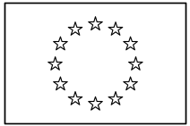 | EUROPEAN COMMISSION  DIRECTORATE-GENERAL  INFORMATICS  Information Systems Directorate

European Commission
CIPADMIN Use Case Specification:
UC0070 - e-TrustEx Admin Console - Manage Transaction

Date: | 20/01/201727/10/2015
Version: | 21.000001
Authors: | Anamaria BATRINU
Revised by:
Approved by:
Public:
Reference Number:
TABLE OF CONTENTS
1. Use-Case Description 6
1.1. Primary Actor 6
1.2. Definitions, Acronyms and Abbreviations 7
1.3. References 7
1.4. Context Diagram 8
1.4.1. CIPA Administration Console 8
1.4.2. Manage Transaction module 9
2. Flow of events 9
2.1. Basic Creation flow 9
2.1.1. User chooses the Create Transaction menu action 9
2.1.2. System displays the "Create Transaction" page 9
2.1.3. User enters information 10
2.1.4. System creates the Transaction 11
2.1.5. User acknowledges the success of the operation 11
2.1.6. System redisplays the saved transaction in view mode 11
2.1.7. The basic creation flow ends. 11
2.2. Basic search flow 12
2.2.1. User selects the Search Transaction menu action 12
2.2.2. System displays the "Search Transaction" page 12
2.2.3. User enters the search criteria 12
2.2.4. The System searches the transactions 12
2.2.5. System displays the transactions found 13
2.2.6. User views the result list 13
2.2.7. The basic search flow ends. 13
2.3. Basic Visualization Flow 13
2.3.1. User has successfully saved a transaction via the creation/modification flow or at step 2.2.6, User selects a Transaction in the list by clicking on it 13
2.3.2. System opens the transaction visualization page (see 7.3."View Transaction" page) 13
2.3.3. User visualises the details of the transaction: 13
2.3.4. Visualization flow ends. 14
2.4. Basic Modification Flow 14
2.4.1. At 2.3.3., User chooses to edit a Transaction 14
2.4.2. System opens the Transaction page in edit mode: 14
2.4.3. User makes the changes 15
2.4.4. The system saves the modified Transaction 15
2.4.5. User acknowledges the successful modification 16
2.4.6. System redisplays the transaction in view mode (see 7.3."View Transaction" page) 16
2.4.7. The Modification flow ends. 16
2.5. Basic Deletion Flow 16
2.5.1. At 2.3.3., User chooses to delete a Transaction 16
2.5.2. System asks for deletion confirmation 16
2.5.3. User confirms the deletion 16
2.5.4. System deletes the transaction 16
2.5.5. System notifies user of the success of the operation 17
2.5.6. User acknowledges the message 17
2.5.7. The Deletion Flow ends. 17
2.6. Alternative Flows 17
2.6.1. AC1: at step 2.1.3, User chooses Cancel option 17
2.6.2. AC2: at step 2.1.3, User chooses Clear option 17
2.6.3. AS1: at step 2.2.4, no transactions found for the specified criteria 17
2.6.4. AS2: at step 2.2.3 or 2.2.6, User chooses Cancel option 17
2.6.5. AM1: at step 2.4.3, User chooses Cancel option 17
2.6.6. AM2: at step 2.4.3, User chooses Reset option 17
2.6.7. A1: at steps 2.1.3 or 2.4.3, User chooses to search for a Document 17
2.7. Exceptional Flows 18
2.7.1. E1: at steps 2.1.1, 2.2.1, 2.3.1, 2.4.1 or 2.5.1 user is not authorized for the operation 18
2.7.2. E2: at step 2.1.4 or 2.4.4 Business Rules are not verified 18
2.7.3. E3: in 2.4 Basic Modification Flow, the transaction is reffered to by at least one message in the System 18
2.7.4. E4: at step 2.5.4 Business Rules are not verified 18
2.7.5. E5: at step 2.1.4, 2.4.4 or 2.5.4 there is an error when saving the transaction 18
2.7.6. E6: at step 2.5.4, there is an error when deleting the transaction 18
2.7.7. E7: at any step, a technical error occurs 18
3. Special Requirements 19
3.1. Interface(s) with other Systems 19
3.2. Security Requirements 19
3.3. Other Special Requirement 19
4. Preconditions 19
5. Post conditions 19
6. Additional Information 19
6.1. Includes 19
6.2. Extends 19
7. Mock-up screens 19
7.1. "Create Transaction" page 19
7.2. "Search Transaction" page 20
7.3. "View Transaction" page 21
7.4. "Modify Transaction" page 21
7.5. "Delete Transaction" page 22
8. Annexes 22
8.1. CIA Levels 22

Document History

Version | Date | Comment | Modified Pages
0.001 | 04/10/2013 | First draft | All
0.002 | 16/12/2014 | Modifications following model change over time
0.003 | 19/02/2015 | Added UC70_BR26 | Section 2.2
1.000 | 21/05/2015 | ETRUSTEX-1010: type code at transaction level | Sections: Basic Creation flow, Mock-up screens
1.001 | 27/10/2015 | CIPADMIN-476: applying minimum length and trimming spaces  CIPADMIN-459: "Any" option in profile lists seems confusing  CIPADMIN-414: Add the transaction version in the search result list | Where needed
1.002 | 24/10/2016 | ETRUSTEX-1392: displaying version with the transaction name to avoid confusion | Where needed
1.003 | 26/10/2016 | ETRUSTEX-1787: Replace "Any" with "Please select" | Search screen
2.000 | 20/01/2017 | ETRUSTEX-1937: Reorganizing CIPAdmin user roles

Use-Case Description
This use case depicts the sequence of actions a user shall follow in order to create a Transaction. It also describes the management actions that correspond to a created Transaction, such as Update, Delete, View and Search.
The "Transaction Management" service is exposed on the CIPAdmin module of e-Trustex platform.
In the remainder of the document the CIPADMIN application will be referred to as the System.

Primary Actor
A human user can access the Manage Transaction feature via CIPAdmin interface.
For detailed user access rights on each feature option, please see UC 0100 - eTrustEx Admin Console - Authenticate and Authorise User, section 6.3 User Access Rights.
In the remainder of the document, the user will be referred to as User.

Definitions, Acronyms and Abbreviations
Acronym, Abbreviation or Definition | Explanation
CIPA | Common Infrastructure for Public Administrations
CIPADMIN | CIPA AdminConsole
ADM | A user having General Administrator role. The General Administrator is the Administrator of the CIPAdmin application.
CBO | A user having Central Business Owner role. The Central Business Owner is responsible for the organization and operation of a business and uses CIPA in his business context.
UC(s) | Use Case(s)
CIA | Confidentiality Integrity Availability

References
Ref. | Reference | Title / description | Version | Date
[R1] | CIPADMIN-VISION | CIPADMIN Vision document | V.61-EN | 18/04/2013

Context Diagram

CIPA Administration Console
The diagram below depicts all the Services available on the CIPA Administration Console for e-TrustEx platform. Depending on the user role, only a subset of those services is exposed on the e-TrustEx Administration Console home page.
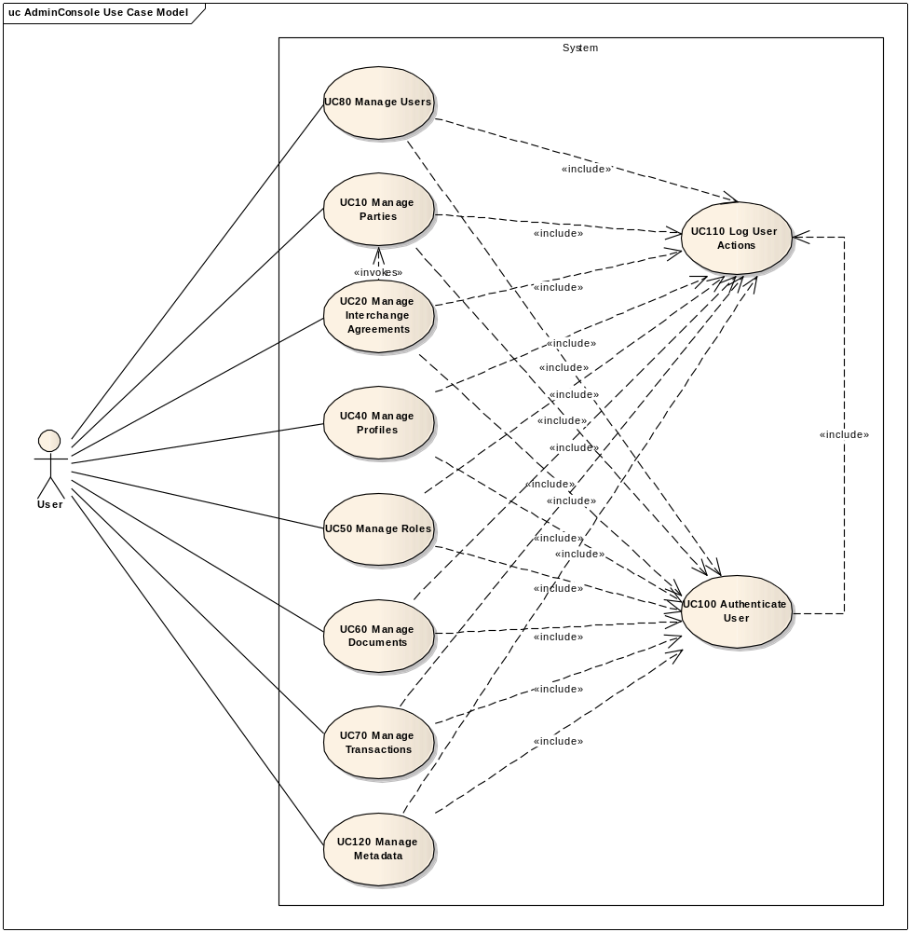

Manage Transaction module
The diagram below depicts how this use case interacts with other use cases implemented in the Administration Console.
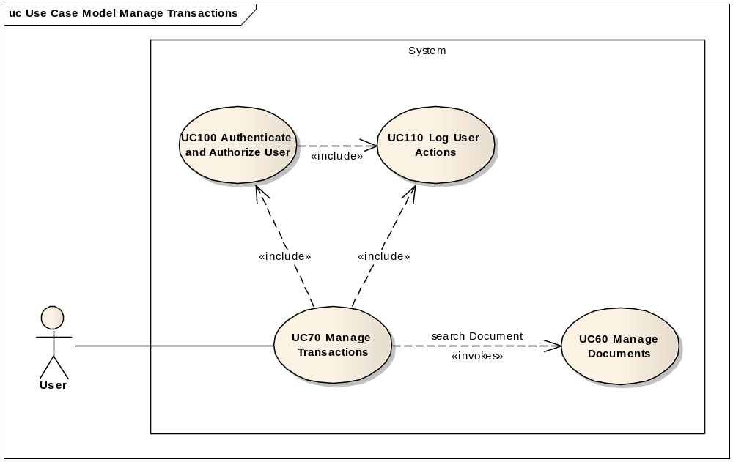

Flow of events
The conventions described in User Interface Generic Conventions document must be applied.

Basic Creation flow

User chooses the Create Transaction menu action
ID | Description
UC70_BR01 | User needs to have the correct access rights in order to access this feature. Please see UC 0100 - eTrustEx Admin Console - Authenticate and Authorise User, section 6.3 User Access Rights for more information.
User selects Technical Configuration > Transaction > Create from e-TrustEx Administration Console home page.

System displays the "Create Transaction" page
The System displays the Create Transaction page as described in paragraph 7.1. "Create Transation" page.

User enters information
ID | Description
UC70_BR02 | After user fills in the transaction name, if the request local name is not already filled in, System defaults request local name to the transaction name followed by "Request" (e.g.: for a transaction called "SubmitInvoice", the default request local name would be "SubmitInvoiceRequest").
UC70_BR03 | After user fills in the transaction name, if the response local name is not already filled in, System defaults response local name to the transaction name followed by "Response".
UC70_BR04 | If profiles have been already selected and user chooses None option, the previously selected profiles will be removed from the selection.  If None option is selected, and user selects any of the profiles in the list, None will be removed from the selection.
Note: Rules UC70_BR02 and UC70_BR03 will ensure a faster configuration, when we use same standards (meaning transaction name + Request/Response suffix).
- User fills in the fields:
- Transaction name
- Transaction namespace
- Transaction version
- The request and response local names
- The type code (optional)
- User chooses a value from the available options for the fields:
- Receiver and sender roles
- CIA levels: defaulted to the most permissive CIA levels; please see 8.1 CIA Levels for more details
- The user can use the search option to find and attach an existing document to the transaction. The document field will display both the document name and the document version. Note: If the transaction is used with a new document, then the user needs first to create the document (see UC 0060 – eTrustEx Admin Console – Manage Document.doc, section 2.1 Basic Creation Flow). The document creation is not directly available from the Transaction creation page.
- Optionally, user can associate the transaction to one or more existing profiles that pertain to the user's current selected business domain. These profiles are made available via a multiple choice list.
- User chooses save option.

System creates the Transaction
ID | Description
UC70_BR05 | Transaction name is mandatory.
UC70_BR06 | Transaction namespace is mandatory.
UC70_BR07 | Transaction version is mandatory.
UC70_BR08 | Transaction document is mandatory.
UC70_BR09 | Request local name is mandatory.
UC70_BR10 | Response local name is mandatory.
UC70_BR11 | Sender role is mandatory.
UC70_BR12 | Receiver role is mandatory.
UC70_BR13 | The transaction name and version must be a unique combination.
UC70_BR14 | The transaction namespace and the request local name must be a unique combination.
UC70_BR15 | Confidentiality, integrity and availability levels are mandatory.
UC70_BR16 | A value shall be always selected in the associated profiles list.  Note: "None" is a valid option, allowing the user to postpone the association of profiles to a transaction, and it is the default option.
UC70_BR27 | All input fields shall have at most 255 characters (transaction name, version, namespace, request and response local names, and document type code).
UC70_BR28 | All input fields, except the transaction version, shall have at least 2 characters.
UC70_BR29 | When saving the fields, the leading and trailing spaces are ignored. This rule shall be applied before verifying UC70_BR27 and UC70_BR28.
- System validates the page according to the business rules.
- System saves the Transaction, and creates a CIA levels record if it does not exist. It also creates the associations between the transaction and the specified profiles if user specified any profile.
- System logs the successful creation of the transaction: include use case Log CIPAdmin User Actions
- System informs the user about the success of the operation.

User acknowledges the success of the operation

System redisplays the saved transaction in view mode
- System goes to step 2.3.2 in 2.3. Basic Visualization Flow

The basic creation flow ends.

Basic search flow

User selects the Search Transaction menu action
ID | Description
UC70_BR01 | User needs to have the correct access rights in order to access this feature. Please see UC 0100 - eTrustEx Admin Console - Authenticate and Authorise User, section 6.3 User Access Rights for more information.

There are two ways of accessing the Search Transaction option:
- By navigating CIPAdmin menu: Technical Configuration > Transaction > Search
- By selecting the Search option from one of the application pages that uses it. Note that, in this case, the search page described in paragraph 7.2. "Search Transaction" page will have a Cancel option allowing the user to leave the search page and go back to the parent page without any information being exchanged.

System displays the "Search Transaction" page
System displays the search page as described in paragraph 7.2. "Search Transaction" page.

User enters the search criteria
- User enters one or more search criteria. A search criterion left empty means the concerned field will not be taken into account.
- User activates the search button.

The System searches the transactions
ID | Description
UC70_BR18 | A field left empty will not be taken into account for the search.
UC70_BR19 | Character case is ignored.
UC70_BR20 | Trailing and leading spaces are ignored.
UC70_BR21 | For the transaction and document name, field value can contain a partial match.
UC70_BR22 | At least one search field should be filled in.
UC70_BR23 | If a single search field is filled in, it needs to contain at least 2 characters.  Note: The fields to be taken into account for this rule are the transaction name and the document name.
UC70_BR26 | If more than one profile is specified in the associated profiles, the System shall search for the transactions that are associated to at least the specified profiles.  Note: This means that there can be transactions in the search results that are associated with other profiles in addition to the selected ones. For example, we have  T1 – P1, P2, P3  T2 – P1, P3  T3 – P1  T4 – P4, P5  T5 – P2, P3  where Ti are transactions, and Pj profiles associated to transactions.  Search on P1, P3 => T1, T2 (both transactions contain at least P1 and P3)  ≠> T1, T2, T3, T5 (T3 and T5 containt only a partial match of the selected profiles: T3 contains only P1, while T5 contains only P3)
The system searches the transactions that satisfy all the entered criteria.

System displays the transactions found
The system displays the list of transactions corresponding to the search criteria, as described in paragraph 7.2. "Search Transaction" page.

User views the result list
- User can view the details of a transaction by clicking on its name in the list (see 2.3. Basic Visualization Flow)
- If called from a master screen instead of the menu option
  - User selects a record in the result list (by clicking on it)
  - System returns the record to the master screen in order to be used by the caller flow
  - Go to section 2.2.7. The basic search flow ends
- User can launch a new search

The basic search flow ends.

Basic Visualization Flow
ID | Description
UC70_BR01 | User needs to have the correct access rights in order to access this feature. Please see UC 0100 - eTrustEx Admin Console - Authenticate and Authorise User, section 6.3 User Access Rights for more information.

User has successfully saved a transaction via the creation/modification flow or at step 2.2.6, User selects a Transaction in the list by clicking on it

System opens the transaction visualization page (see 7.3."View Transaction" page)

User visualises the details of the transaction:
- User can choose to edit or to delete a Transaction (see 2.4 Basic Modification Flow and 2.5. Basic Deletion Flow), if he/she has the corresponding access rights. Please see UC 0100 - eTrustEx Admin Console - Authenticate and Authorise User, section 6.3 User Access Rights for more information on user access rights.
- User can choose Cancel option, to leave the visualization screen:
  - If Visualization <= Search (i.e. visualization initiated from Search flow) or Visualization <= Modification <= Visualization <= Search (i.e. visualization initiated from Modification flow, and Modification flow called from the visualization flow that followed a search flow), System returns the User to the search screen: the view flow ends and basic search flow continues at 2.2.6
  - If Visualization <= Creation or Visualization <= Modification <= Visualization <= Creation, System return the User to a new creation screen: the view flow ends and a new basic creation flow starts

Visualization flow ends.

Basic Modification Flow
ID | Description
UC70_BR01 | User needs to have the correct access rights in order to access this feature. Please see UC 0100 - eTrustEx Admin Console - Authenticate and Authorise User, section 6.3 User Access Rights for more information.
UC70_BR24 | Transaction modification is not authorized if there are messages in the System referring to the transaction. This check shall be done twice:  - First, when trying to acces the modification page  - Second, when trying to save a modified transaction (in order to ensure that no message using this transaction has been received in the meanwhile)  Note: This serves to avoid inconsistency with messages sent before this point, and messages sent after this point. There is still a very small chance that this will happen, in the milliseconds between the second check and the execution of the save operation.

At 2.3.3., User chooses to edit a Transaction

System opens the Transaction page in edit mode:
System displays the Transaction page in edit mode as described in section 7.4."Modify Transaction" page.

ID | Description
UC70_BR05 | Transaction name is mandatory.
UC70_BR06 | Transaction namespace is mandatory.
UC70_BR07 | Transaction version is mandatory.
UC70_BR08 | Transaction document is mandatory.
UC70_BR09 | Request local name is mandatory.
UC70_BR10 | Response local name is mandatory.
UC70_BR11 | Sender role is mandatory.
UC70_BR12 | Receiver role is mandatory.
UC70_BR13 | The transaction name and version must be a unique combination.
UC70_BR14 | The transaction namespace and the request local name must be a unique combination.
UC70_BR15 | Confidentiality, integrity and availability levels are mandatory.
UC70_BR16 | A value shall be always selected in the associated profiles list.  Note: "None" is a valid option, allowing the user to postpone the association of profiles to a transaction, and it is the default option.
UC70_BR17 | If the transaction is associated with any profiles and User specifies "None" option, the System will remove currently associated profiles which belong to the current selected business domain, but not associated profiles that belong to other business domains. This needs to be done in order not to impact the business configurations and behaviour of other business domains.
UC70_BR27 | All input fields shall have at most 255 characters (transaction name, version, namespace, request and response local names, and document type code).
UC70_BR28 | All input fields, except the transaction version, shall have at least 2 characters.
UC70_BR29 | When saving the fields, the leading and trailing spaces are ignored. This rule shall be applied before verifying UC70_BR27 and UC70_BR28.

User makes the changes
- User makes the desired changes
- User chooses the save option

The system saves the modified Transaction
- The system validates the page according to the business rules.
- System saves the Transaction, and creates a CIA levels record if it does not exist. It also updates the profile associations depending on user selection.
- System logs the successful modification: include use case Log CIPAdmin User Actions
- The System informs the user about the success of the operation

User acknowledges the successful modification

System redisplays the transaction in view mode (see 7.3."View Transaction" page)

The Modification flow ends.

Basic Deletion Flow
ID | Description
UC70_BR01 | User needs to have the correct access rights in order to access this feature. Please see UC 0100 - eTrustEx Admin Console - Authenticate and Authorise User, section 6.3 User Access Rights for more information.

At 2.3.3., User chooses to delete a Transaction

System asks for deletion confirmation

User confirms the deletion
If user chooses to cancel the deletion, he is returned to the visualization page (2.3.3.).

System deletes the transaction
ID | Description
UC70_BR25 | To be deleted, the transaction shall not be used in:  - Endpoint configurations  - log records  - Messages  - Metadata configurations  - Message response codes  - SLA policy configurations  - Party agreements  - Profiles  - Retention policy configurations  - Service endpoint configurations

- System verifies the business rules
- System deletes transaction
- System logs the successful deletion: include use case Log CIPAdmin User Actions

System notifies user of the success of the operation

User acknowledges the message

The Deletion Flow ends.

Alternative Flows

AC1: at step 2.1.3, User chooses Cancel option
- System disregards all information provided by User
- System closes the page
- System redirects the user to CIPAdmin home page
- Use Case ends

AC2: at step 2.1.3, User chooses Clear option
- Systems disregards all information provided by the user
- Alternate flow ends and basic creation flow restarts at 2.1.2.

AS1: at step 2.2.4, no transactions found for the specified criteria
- System notifies User that no transacions have been found
- Alternate flow ends and basic search flow restarts at 2.2.3

AS2: at step 2.2.3 or 2.2.6, User chooses Cancel option
- System closes Search screen
- System returns to parent screen
- Search flow ends and caller flow can now continue

AM1: at step 2.4.3, User chooses Cancel option
- User chooses Cancel option
- System disregards all information provided by User
- Alternate flow ends and basic flow continue from step 2.3.2

AM2: at step 2.4.3, User chooses Reset option
- Systems disregards all information provided by the user
- Alternate flow ends and basic modification flow restarts at 2.4.2.

A1: at steps 2.1.3 or 2.4.3, User chooses to search for a Document
- System opens a Document Search Popup: include section 2.2. Basic Search Flow (from step 2.2.2. System displays the Search Document page) of Manage Document Use Case.
- System fills in the read-only input text with the document id of the document returned at previous step
- Alternate flow ends and basic flow continues at 2.1.3, respectively 2.4.3.

Exceptional Flows

E1: at steps 2.1.1, 2.2.1, 2.3.1, 2.4.1 or 2.5.1 user is not authorized for the operation
Include the steps in section 2.4.1 of Authenticate and Authorise User Use Case.

E2: at step 2.1.4 or 2.4.4 Business Rules are not verified
- System logs the error: include use case Log CIPAdmin User Actions
- The System displays the error messages.
- Flow restarts at 2.1.3, respectively 2.4.3.

E3: in 2.4 Basic Modification Flow, the transaction is reffered to by at least one message in the System
- System logs the error: include use case Log CIPAdmin User Actions
- The System informs the user about the error and does not open the modification page.
- The Use Case ends

E4: at step 2.5.4 Business Rules are not verified
- System logs the error: include use case Log CIPAdmin User Actions
- The System displays the error messages.
- User acknowledges the message
- Flow restarts at 2.3.3.

E5: at step 2.1.4, 2.4.4 or 2.5.4 there is an error when saving the transaction
- System logs the error: include use case Log CIPAdmin User Actions
- The system informs the user about the error.
- Use case ends.

E6: at step 2.5.4, there is an error when deleting the transaction
- System logs the error: include use case Log CIPAdmin User Actions
- The system informs the user about the error.
- Use case ends.

E7: at any step, a technical error occurs
- System logs the error: include use case Log CIPAdmin User Actions
- The system informs the user about the error.
- Use case ends.

Special Requirements

Interface(s) with other Systems

Security Requirements

Other Special Requirement

Preconditions
N/A

Post conditions
- [Success] The Transaction has been successfully created / modified / visualised / deleted.
- [Failure] The use case is aborted and the primary actor has been notified of the reasons.

Additional Information

Includes
- For operation authorization: UC 0100 - eTrustEx Admin Console - Authenticate and Authorise User
- For logging: UC 0110 - eTrustEx Admin Console - Log CIPAdmin User Actions
- For searching a document: UC 0060 - eTrustEx Admin Console - Manage Document

Extends
N/A

Mock-up screens

"Create Transaction" page
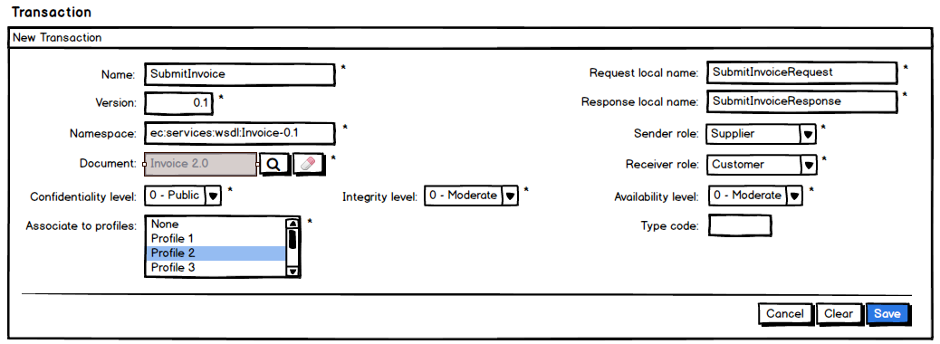
- The System retrieves all available roles and populates the receiver and sender role lists
- The System populates the lists for the CIA levels with the levels and their descriptions. Please see 8.1 CIA Levels for more details. The selection shall be defaulted to the most permissive CIA levels.
- The System retrieves all profiles corresponding to the selected business domain, and populates the profile multiple choice list. Option "None" is also available for allowing the user to create a transaction without associating a profile to it. The default selection is set to "None".
- Role and profile lists are ordered in ascendant alphabetical order and ignoring case.
- The transaction document field is read only. It is automatically filled in by the system with the document name and version when user selects a document in the search document page that can be accessed via the search button next to the document field.
- The clear button, next to document read only field, gives the option to clear the selected document
- Starred fields are mandatory.
- Clear, Cancel and Save options are present.

"Search Transaction" page
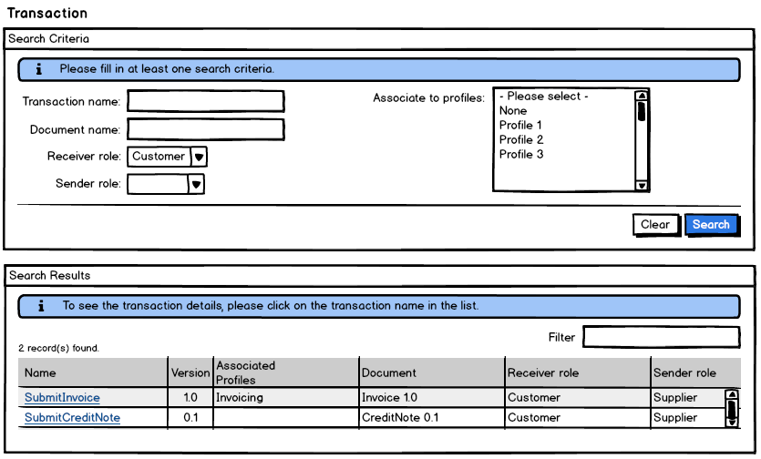
- The System retrieves all available roles and populates the receiver and sender role lists
- The System retrieves all profiles corresponding to the selected user business domain and populates the multilist. The multilist has also a placeholder ("--Please select--"). A special option

- ("None") allows the user to search for transactions that are not linked to any profile of the selected user business domain (it can be used to search for orphan transactions or newly created ones).
- Role and profile lists are ordered in ascendant alphabetical order and ignoring case.
- Search results are ordered by transaction name in ascendant alphabetical order and ignoring case, and provide the following information:
  - Transaction name
  - Transaction version
  - Associated profiles
  - Document name and version
  - Receiver role
  - Sender role

"View Transaction" page
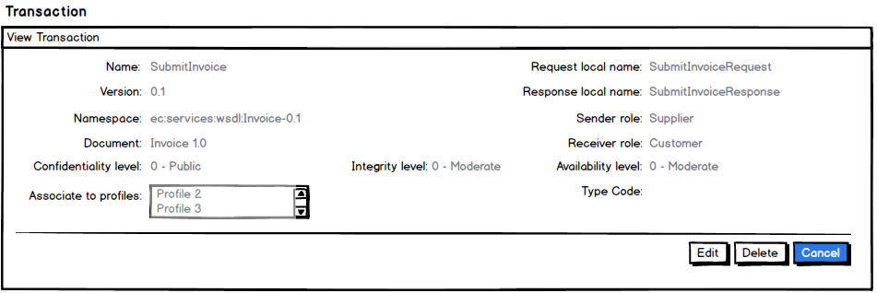
- All fields are protected
- "Cancel", "Edit" and "Delete" buttons are made available

"Modify Transaction" page
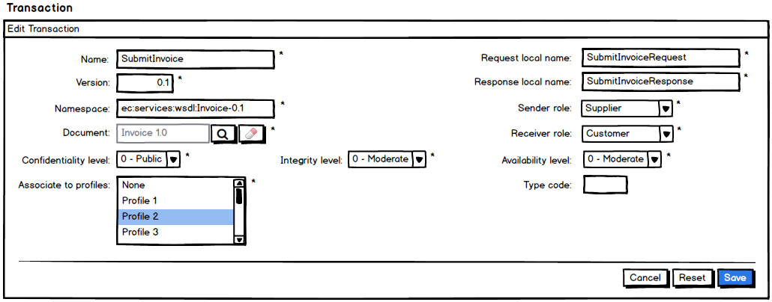
- See points (1) to (7) from section 7.1 "Create Transaction" Page
- All fields can be modified;
- "Cancel", "Reset" and "Save" options are present.

"Delete Transaction" page
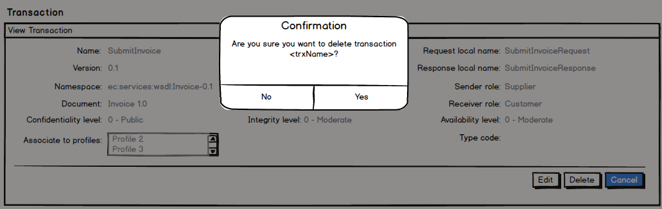

Annexes

CIA Levels
The possible values for CIA levels can be found in the table bellow:
Classification criteria | Level | Description
Confidentiality | 0 | PUBLIC
Confidentiality | 1 | LIMITED BASIC
Confidentiality | 2 | LIMITED HIGH
Integrity | 0 | MODERATE
Integrity | 1 | CRITICAL
Integrity | 2 | STRATEGIC
Availability | 0 | MODERATE
Availability | 1 | CRITICAL
Availability | 2 | STRATEGIC
The most permissive levels are the lowest levels. The higher a CIA level, the less permissive it becomes.

